Green Card Scheme: Denmark

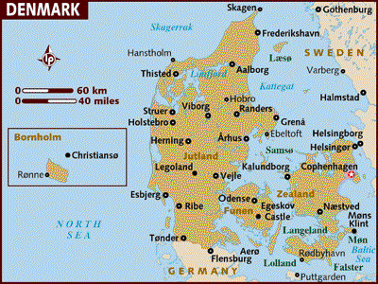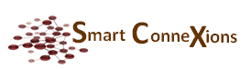

Denmark Forecast in Business Environment

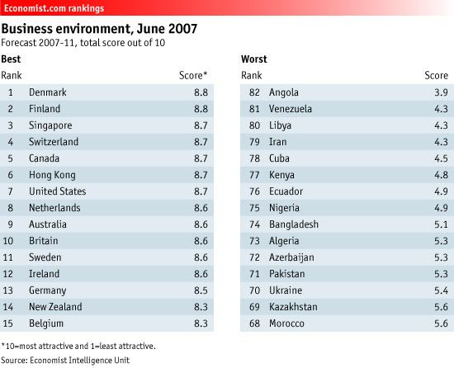
Denmark (Scandinavian country) has got the worlds highest per capita income / GDP... 20% more than US, 35% more than UK and much higher than many other European countries.... it is very very very easy to find a job there,

And an average person earns about 2 to 3 lacs Denmark currency which is 55 to 80 thousand USD per annum much higher than the US salary

It is possible to be granted a three-year residence permit for the purpose of seeking work, and subsequently working, in Denmark. A residence and work permit under the Green card scheme is issued on the basis of an individual evaluation using a point system designed to assess the likelihood that the applicant will be able to find qualified work in Denmark.

Facts about Denmark

Denmark is located in Northern Europe, in the region that is called Scandinavia. Denmark is located to the north of Germany and to the south/southwest of Norway and Sweden.
- Denmark is an island nation measuring about 43,000 square kilometres. It consists of the peninsula, Jutland and 474 islands, of which Zealand, Funen, Lolland, Falster and Bornholm are the largest.
- Denmark has 5.5 million residents. Of these, approximately 300,000 are foreign nationals, 64% of whom come from Scandinavia, the EU or North America. As of 1 January 2007, there were approx. 480,000 immigrants and their descendants in Denmark. There is also a German minority residing in Southern Jutland that comprises approx. 5 percent of the population.
- The capital city of Denmark is Copenhagen, located on the island of Zealand. There are approx. 1.25 million residents in Greater Copenhagen.
- The official language of Denmark is Danish. English is obligatory in primary schools and is spoken and understood by nearly all Danes. A great number of Danes also speak and understand German. Danish, Norwegian and Swedish are very similar and are understood by residents of Denmark, Norway and Sweden.
- The currency is the Danish krone. Even though Denmark is a member of the EU, Denmark has not adopted the euro, therefore Danish stores are not obliged to accept payments in euro.
Why Denmark:
Good conditions and opportunities for development 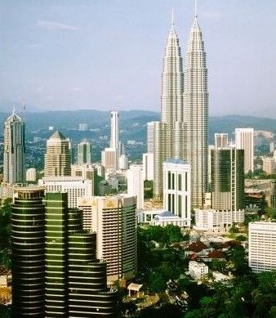
Danish business culture is characterized by a horizontal structure and open dialogue between management and employees, and much is done to ensure a good working environment. Danish companies offer good working conditions, modern facilities and high-quality technical equipment. Competence development is highly prioritized and most workplaces regularly offer continuing education to their employees.

Family and career – a healthy balance

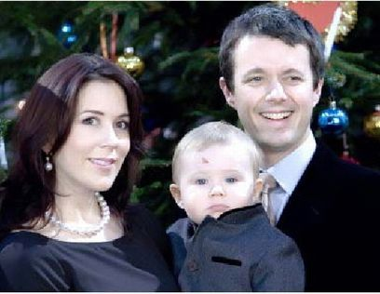
Previous studies have shown that a majority of foreign national workers in Denmark felt that their quality of life increased while living in Denmark. This is the result of many factors, but many highlight the positive balance between family and career in Denmark:
- Nearly all respondents said that their families enjoyed living in Denmark
- A majority of respondents felt that Denmark is a good place to raise children
- Many felt that Danish companies are good at respecting employees' family lives
- Generally, there is a high level of satisfaction with leisure and cultural opportunities in Denmark.

Denmark has a world-class business community

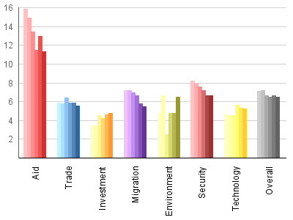

Denmark is known for being among the world leaders in a number of fields of production and services, e.g. agricultural goods, furniture and clothing, interior design, sea freight, wind turbines, medicines and assistive medical technologies, equipment for automatic cooling and heating, sensitive measuring instruments, IT and communications, etc.

Earning potential:

UK, Minimum wage is 5.75 GBP per hour I.E people earn INR 431 (Exchange rate @75 INR), if you do odd jobs and other unskilled Job ( like working in store and Petrol Pump)

US Minimum Wage is 6.55 Dollar per hour, I.e. People Earn INR 294 ( Exchange rate @ 45 INR)

Denmark Minimum Wages in USD per Hour is 12 USD, I,e 600 Appoxmately per hour, which a person can earn by doing ODD Jobs.

Eligibility:

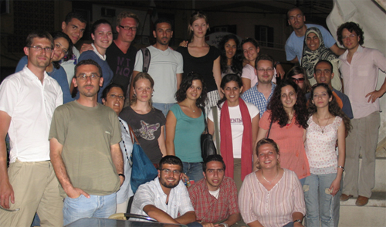

In order to be granted a residence permit under the Greencard scheme, you must attain at least 100 points. Points are given for: educational level, language skills, work experience, adaptability, and age.

Education: Maximum Points: 80

Your educational level will be assessed after it has been converted to its Danish equivalent for comparison. This is done as academic degrees vary from country to country, even if they are called by the same name.

English Language: Maximum Points: 30

Your language skills will be given points based on a four-level system modelled after the official Danish language proficiency tests for foreigners (the Danish Language Test, Levels 1, 2 and 3 and the Study Test in Danish as a Second Language).

Work Experience: Maximum Points 15

Your work experience can be given points according to how many years, within the last five year.

Adaptability: Maximum Points 15

You can be given points for your educational or work related attachment to the EU/EEA (including Denmark) or Switzerland, as this is seen to increase your ability to quickly adapt to the Danish labour market. Points are given for either education or work

Age: Maximum Points 15

You can be given points based on your age.

About Smart ConneXions:

Smart ConneXions is a Immigration Consultancy Based at Hyderabad, which Provides A-Z Services in Immigration, From Work Permit, Green Card, Visit, Student, Business Visa’s to all countries depending on the Eligibility.

Services:

We Provide you tailor made Immigration Solutions depending on your Dreams.

Charges:

Can challenge Market Rate of any kind of Visa to any country and more of quality and Value added Services.

Contact Person:

D. Reena Monica

Immigration Consultant,

